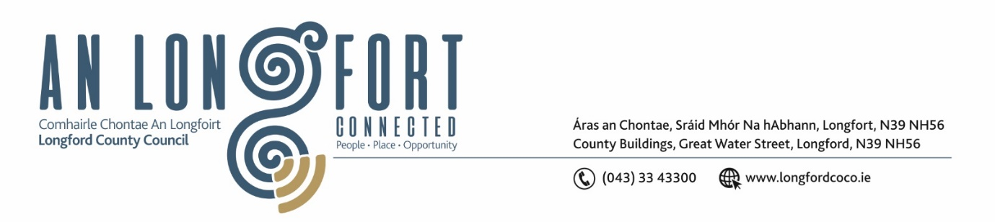

***Please note meeting will be held via Microsoft Teams.***

10 February 2022.

**Chuig: Gach Ball don Chomhairle.**

A Chomhairleoir,

Iarrtar ort bheith i láthair ag Cruinniú Míosuil Chomhairle Chontae Longfoirt a tionólfar via MS Teams are an **16ú Chéadaoin 2022 ag** **3pm** chun gnó a dhéanamh d’réir an Chláir thíos.

You are requested to attend the Monthly Meeting of Longford County Council to be held **via Microsoft Teams** on **Wednesday 16 February 2022 at 3pm** to transact business, as set out on the Agenda hereunder.

Mise le meas,

*Ann Marie Mc Keon*

**__________________**

**Ann Marie Mc Keon**

**Meetings Administrator.**

**C L Á R**

Prayer before meeting.

**1.** Confirmation of Minutes of

(i) Monthly Meeting of Longford County Council held on 19 January 2022 – copy enclosed.

(ii) Committee Meeting of Longford County Council held on 19 January 2022 – copy enclosed

(iii) Committee Meeting of Longford County Council held on 12 January 2022 –

copy enclosed.

**2.** Matters Arising.

**3.** Declaration of Interest by Members.

**4.** To note Management Report – enclosed.

**5.** To note adopted Minutes of Corporate Policy Group Meeting held on the

7 December 2021 – enclosed.

**6. Finance**

**(a)** To note adopted Minutes of meeting of Governance Strategic Policy

Committee held on the 19 October 2021 – enclosed.

**7. Community, Corporate and Enterprise**

**(a)** To note adopted minutes of meeting of Placemaking Strategic Policy

Committee held on the 18 October 2021 - enclosed.

**(b)** Adoption of Service Delivery Plan 2022 – enclosed.

**(c)** Ethical Framework for Local Government - enclosed

**(d)** Approval of the appointment of Michael Reilly Revamp Manager to the Climate Action and Planning Strategic Policy Committee to replace Marcella O Connor from Revamp.

**(e)** Consideration to approve grant under the 2022 Intercultural Grants Scheme – enclosed.

**(f)** Agree date for “In Committee” meeting to discuss updates on Draft Civic Protocols December 2016.

**(g)** Date of March 2022 County Council meeting.

**8. Planning and Project Delivery**

**(a)** To note Planning Applications received since last meeting of the Council.

**(b)** To note adopted minutes of meeting of Climate Action and Planning Strategic Policy

Committee held on the 20 October 2021 – enclosed.

**(c)** Item referred from Climate Action and Planning Strategic Policy Committee Meeting held on the 21 January 2022 –

“Proposed arrangements including fees associated with the recently constructed Columbarium Wall at Ballymacormack Cemetery” – enclosed.

**9. Infrastructure, Housing and Innovation**

**(a)** To note adopted minutes of meeting of Strategic Infrastructure Strategic Policy

Committee held on the 21 October 2021 – enclosed.

**(b)** Item referred from Strategic Infrastructure Strategic Policy Committee meeting held

on 3 February 2022 –

“Policy on signage for children at play” – enclosed.

**(c)** Consideration of the disposal of Terraced House at 3 St. Josephs Road, Longford accordance with the terms of Section 183 of the Local Government Act 2001 issued on the 27 January 2022.

**(d)** Notice of Motions, submitted by Councillors, as listed hereunder –

**Councillor Gerry Warnock**

(i) I am calling on Longford County Council to write to the Minister for Housing to again,

impress on him the urgent requirement for an upwards review of Income Thresholds to

allow people to access Housing Supports. Given the current high cost of private rents

and the predicted upwards trajectory in this regard, the current thresholds are in no way

adequate to deal with the existing crisis. There are many households where the current

measures taken under Housing for All is simply not an option, and these people need

access to traditional supports.

(ii) I'm calling on Longford County Council to install Dog Waste Bins and Bag Dispensers at points on all of our public walkways throughout the County. The issue of dog fouling on our walkways is getting completely out of hand and extremely difficult to police so we need to have these facilities in situ so the offenders have absolutely no

excuse to justify their inconsiderate actions.

**10. General**

Notice of Motions, submitted by Councillors, as listed hereunder –

**Councillor Peggy Nolan**

(i) I am asking my colleagues to support the campaign of parents of children with spina

bifida in their demand for timely surgical orthopaedic management this is a situation that has gone on for too long and has greatly affected the development and abilities of these children.

(ii) “I call on Longford County Council to support the upgrading of the Dublin to Sligo

Railway line to fast track and to support the opening of the closed stations on this

line”.

**11. Correspondence**

Correspondence dated 13 December 2021 received from the Minister of Health -Re Notice of Motion from Councillor Pat O’Toole on Home Support Services – enclosed.

**12. Training**

**13. Votes of Sympathy**